

Challenge Activity: Final UI

Data Analytics and Artificial Intelligence Tools 2 (Gpo 101)

Team: Le Frites

Names and IDs:

Humberto Gonzalez Escamilla - A00837328
Arath Mendivil Mora - A01660670
Lázaro Rodríguez Bedolla - A00838171
Marius Ismael Calves - A01831309
Andrés Montemayor Tatum - A01383664

December 2, 2025
1. Introduction
This dashboard was developed for Whirlpool to visualize historical sell-out performance and to generate data-driven weekly price and quantity predictions using XGBoost models.
The dashboard has two main pages:
- Historical Overview: Displays insights about SKU and Trade Partner behavior across time.
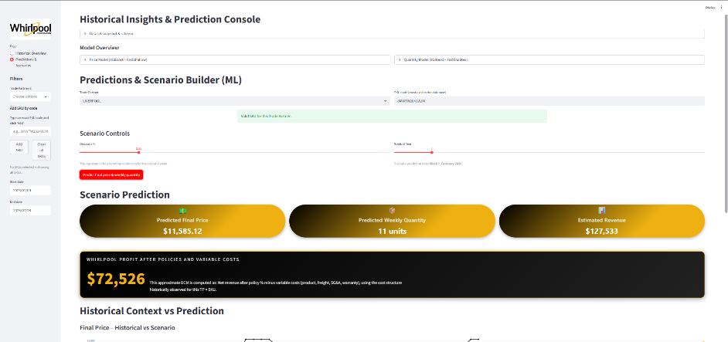
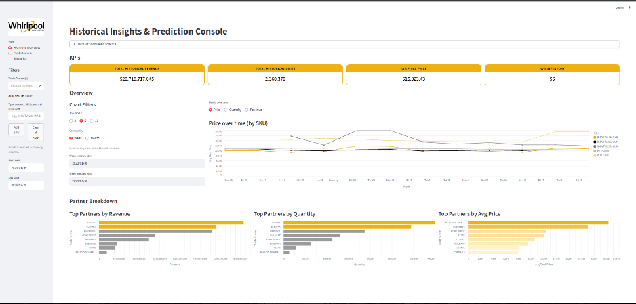
- Predictions & Scenario Builder: Allows the user to simulate future scenarios and get an optimal weekly price, quantity, revenue and profit (DCM).

2. Dashboard structure and pages
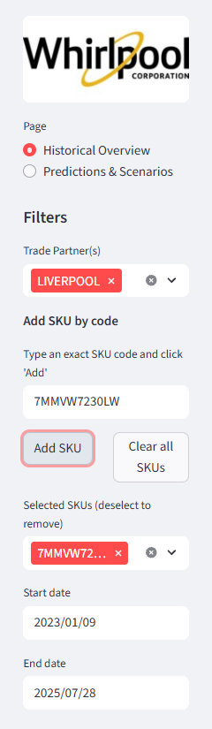
The sidebar provides global filters that affect every visualization and KPI on the Historical Overview page.
- Whirlpool Logo
- Page Selector: Switch between Historical Overview and Predictions & Scenarios.
- Trade Partner Selector: Multi-select filter for TP_GROUP.
- SKU Input Box: Users manually type SKU codes to add/remove.
- Selected SKU List: Used to focus the dashboard on particular products.
- Date Picker: Start and end dates to restrict the historical window.

3. Page 1 - Historical overview
A. KPIs
These KPIs summarize historical performance under the current filters:
- Total Historical Revenue
- Total Historical Units
- Average Final Price
- Average Inventory

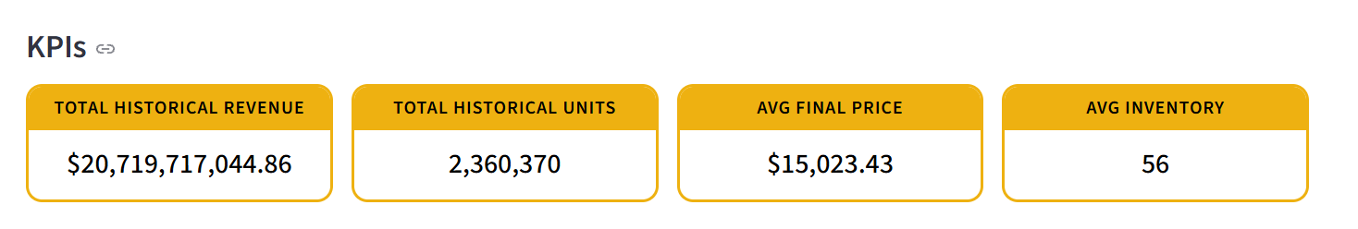
They dynamically update based on the sidebar filters.

B. Chart filters (local controls)
These filters ONLY affect the charts (not KPIs):
- Top-N SKUs: Select whether to plot top 3, 5, or 10 SKUs.
- Granularity: Week, Month, or Quarter.
- Weekly Window: When “Week” is selected, restrict the range to a 12-week slice.

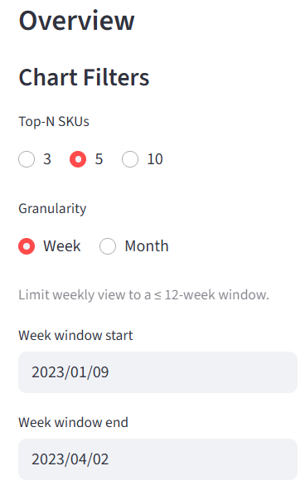
These allow the user to analyze patterns at different resolutions.

C. Time-Series line chart
A dynamic line chart showing:
- Price, Quantity, or Revenue over time
- Broken down by SKU
- Colored by SKU
- Responsive tooltips and zooming

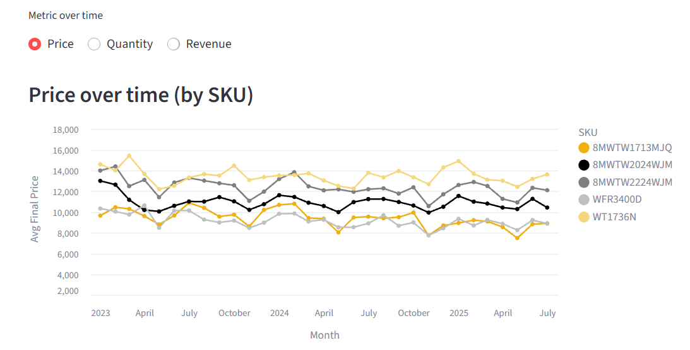
Granularity and Top-N controls modify this visualization.

D. Partner breakdown - Three bar charts
Three partner-focused analyses:
- Top Partners by Revenue
  - Highlights the top 2 partners in custom colors
  - Ranks partners by total revenue in the filtered period
- Top Partners by Quantity
  - Highlights top 2 high-volume partners
  - Shows units sold per partner
- Top Partners by Average Price
  - Gradient-colored bars: darker = higher average price
  - Useful for understanding price positioning
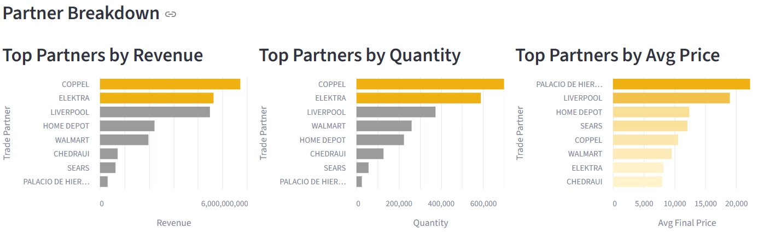
4. Page 2 - Predictions & Scenarios
A. ML Model Explanation Section
This section explains:
- The XGBoost architecture used
- Key features (lags, rolling windows, discount %, seasonality, costs)
- Hyperparameters
- Performance metrics:
  - RMSE
  - MAE
  - R²
  - MAPE

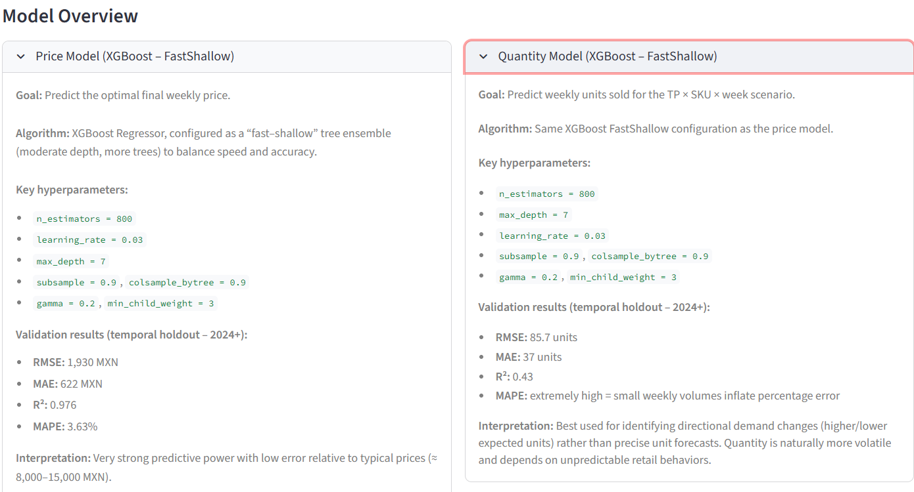
Purpose: Provide transparency on what the ML system is doing.

B. Scenario inputs
Inputs required to generate a weekly forecast:
- Trade Partner selection
- SKU code validation system
- Week of the year (1 - 52) > mapped to a future 2026 date
- Discount input for the promotional intensity of the scenario

If the SKU does not exist for a partner, it warns the user.
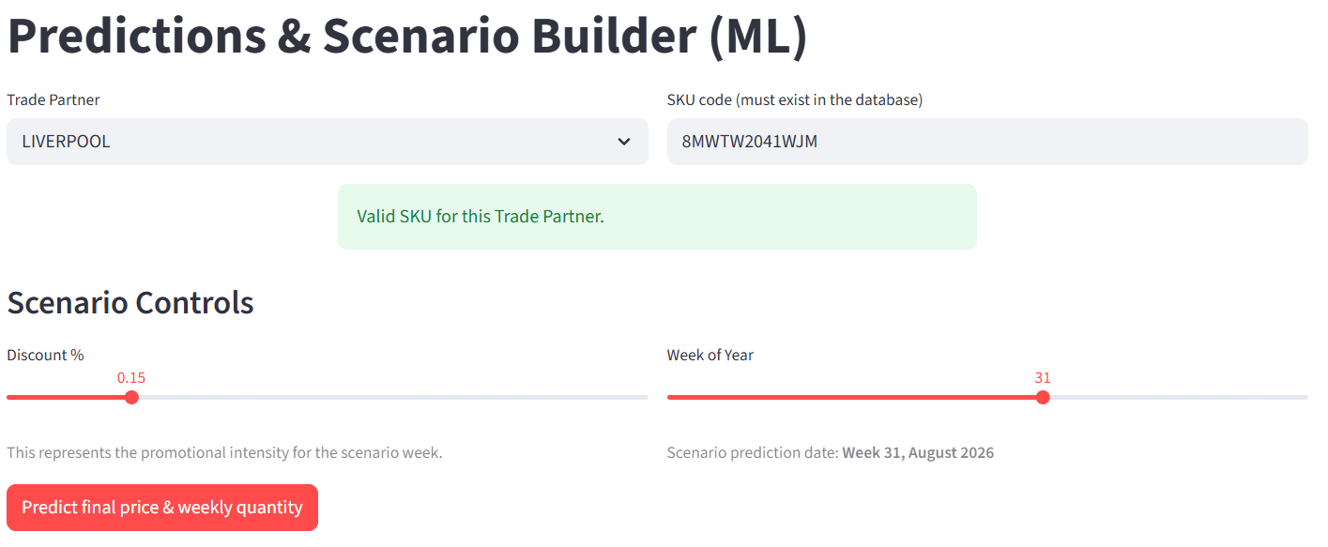

C. Scenario prediction cards
Once the optimal discount is found, the dashboard displays:
- Predicted Final Price
- Predicted Weekly Quantity
- Estimated Revenue

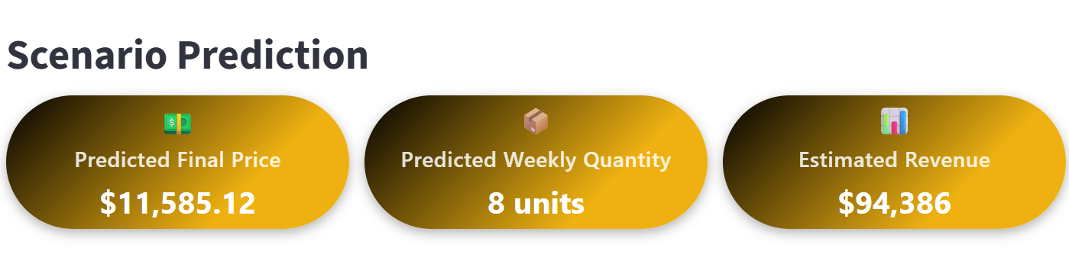
These KPIs use XGBoost predictions + engineered scenario features.

D. Whirlpool profit (DCM) highlight box
This element displays the Whirlpool profit after policies and variable costs, using:
- Policy % (POLICY column)
- Variable cost structure (VPC, WTY, VAR_FW, VAR_SGA)
- Exchange rate to convert USD costs to MXN
- Revenue after applying policy rate
- DCM = Net Revenue – Variable Costs

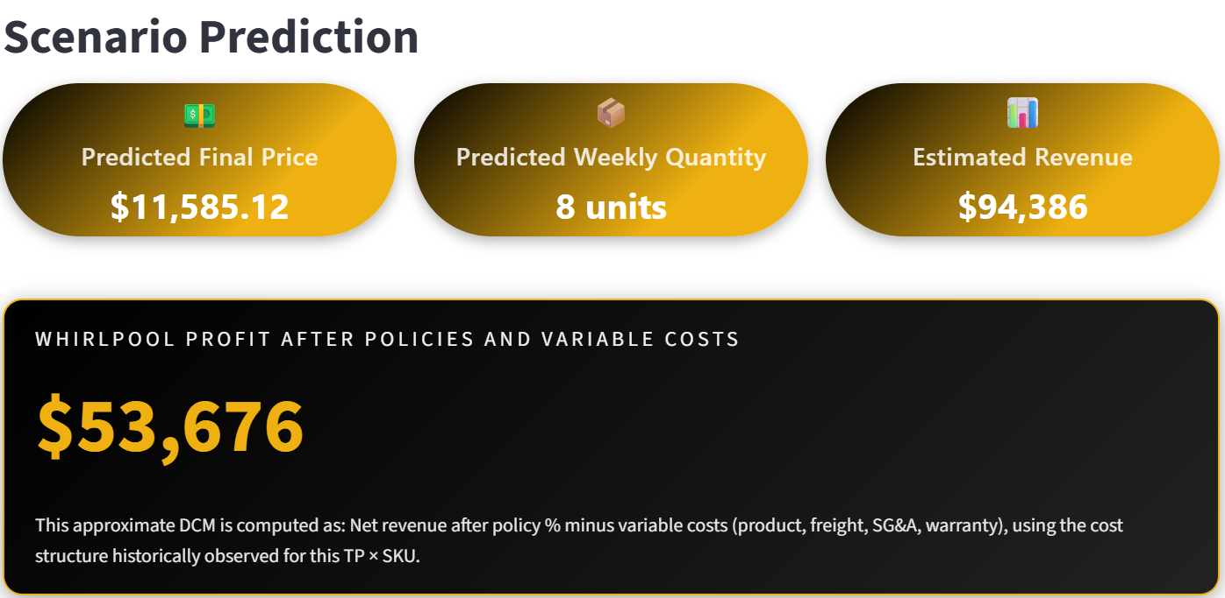
This is the final business-relevant output of the prediction engine.

F. Historical vs Scenario charts
These charts compare:
- Past 1.5 years of history (blue line)
- Future prediction point (yellow dot)

They let users visually validate:
- Trend changes
- Whether the prediction is aligned with historical patterns
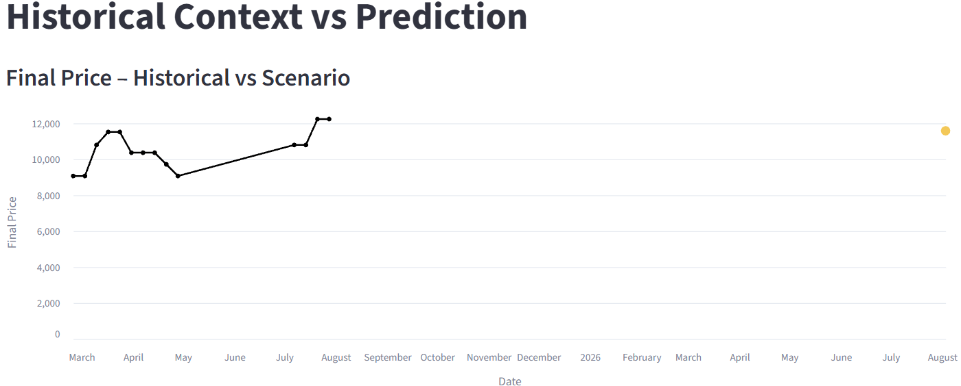
- If the predicted price/qty makes sense
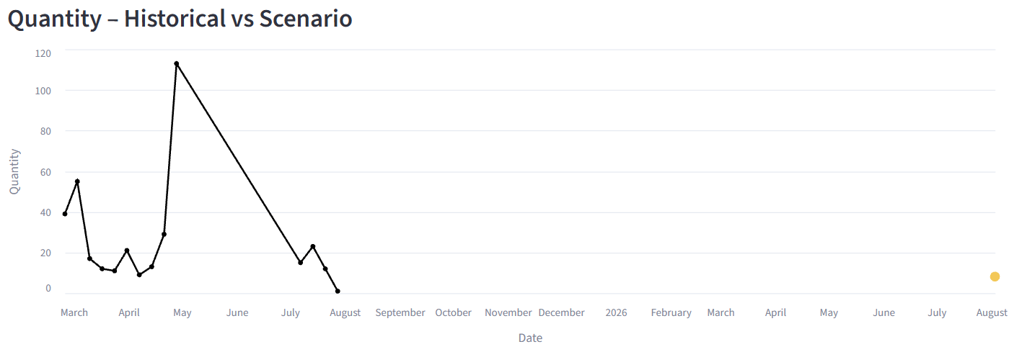

5. Scroll-to-top button
A small square button that scrolls back to the top appears below all content for each page, when clicked, it instantly scrolls the page to the top anchor.
This improves usability, especially on long pages filled with charts and text.
